Prerequisite for VPC:

1. Internet gateway.
2. Public and private subnet.
3. Nat gateway.
4. Route Table.
5. Security Group.
6. EC2 instance.

Step to create VPC:

1. Create VPC.
2. Create **Internet Gateway** and attached to VPC.  
   Step to attach **internet gateway** to VPC:
3. Goto **Internet gateway** Dashboard.
4. Then select **Internet Gateway** which you want to attach to VPC.
5. Then Click on **action** and then click on **attach to VPC**.

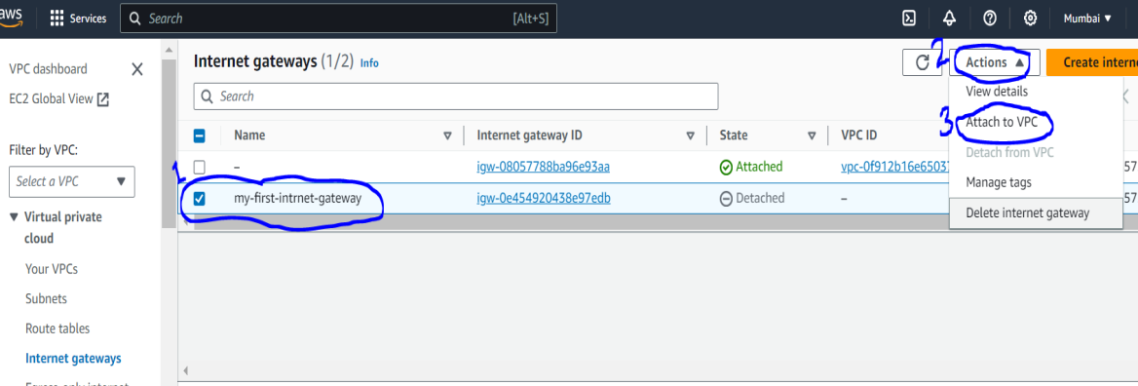

1. You will get below page and then select VPC from available VPC.

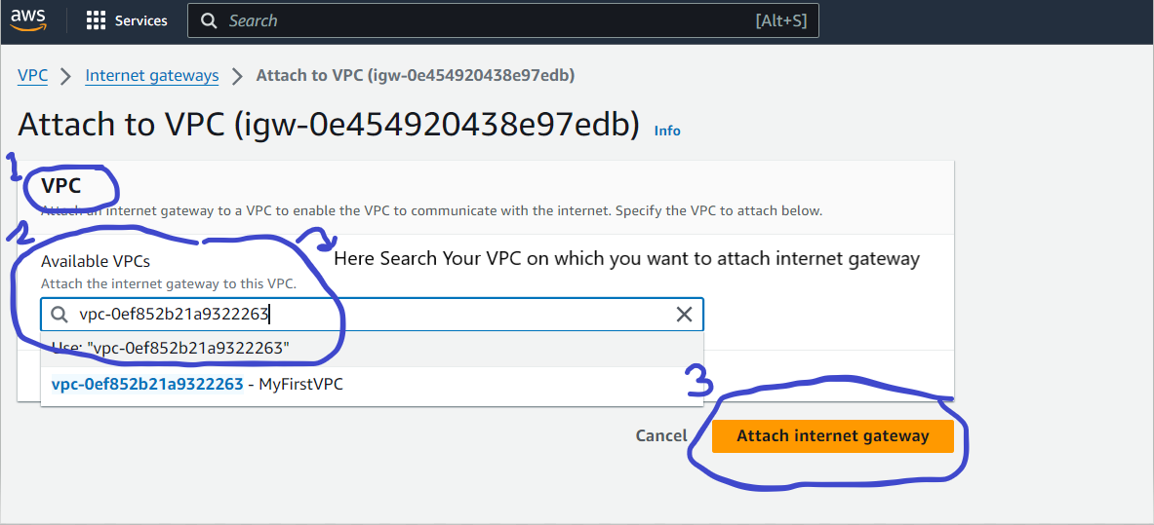

1. Then Create Public Subnet.
2. Create Private Subnet.
3. Then Create Nat Gateway (it is responsible to provide internet to private subnet and also mask private ip) in public subnet and also assign one **elastic IP** **to Nat gateway**.
4. Then Create two Route Table in VPC:
5. One is for allow all traffic to internet gateway called as public route table(we can put any name)
6. Other one is for allowing all traffic of private subnet to Nate gateway called as private route table (we can put any name).
7. Then Select **Public Route** and goto **Routes** section and then click on **Edit routes** and then click on **add route** and then allow all traffic to internet gateway.

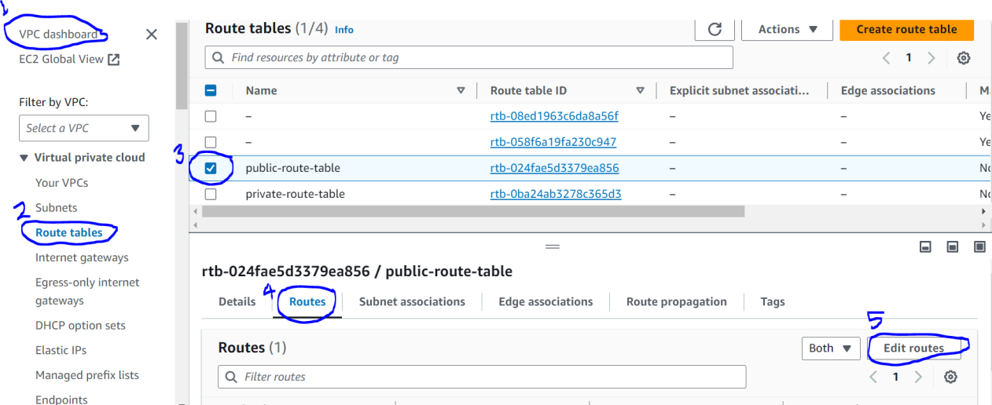

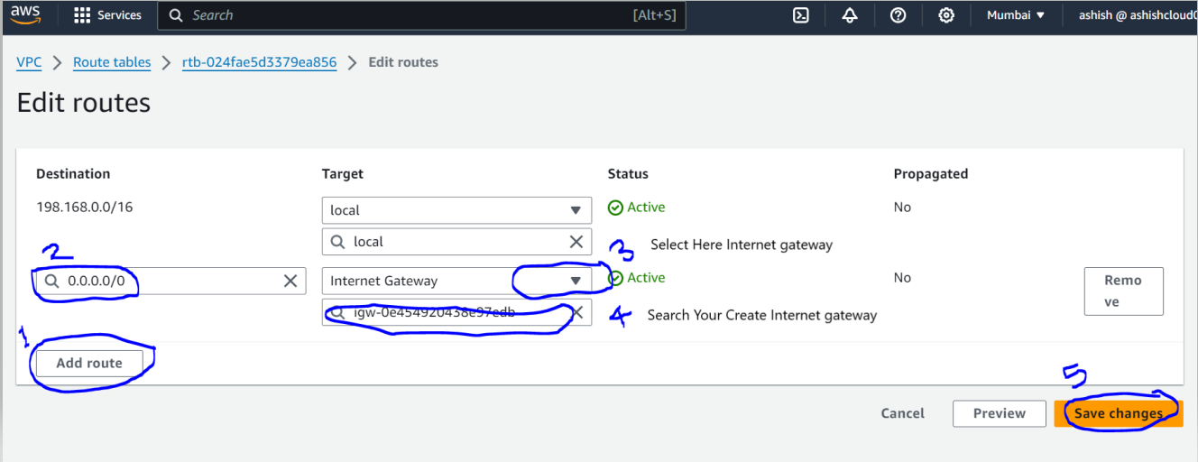

1. Then select **subnet associations** section and then click on **Edit subnet associations** and then select **public subnet**.

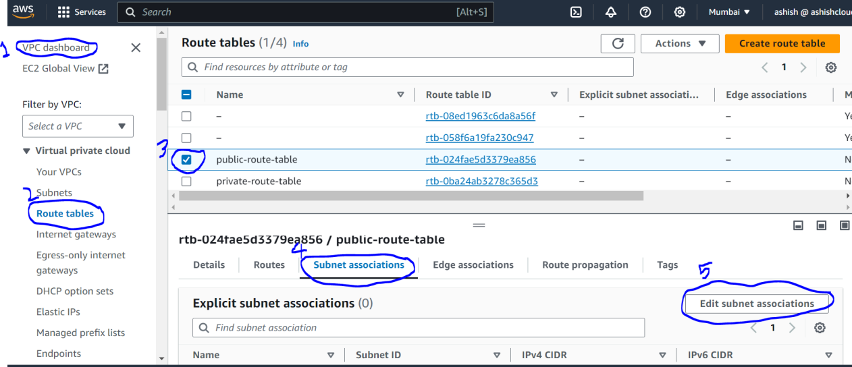

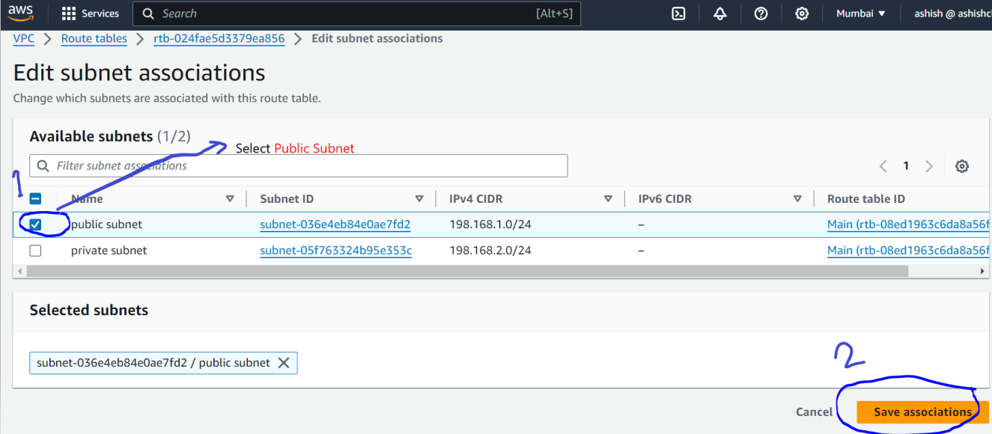

1. Above step do for **private route** but instead internet gateway select **Nat Gateway** and alsoassociate **private subnet** to **private route.**

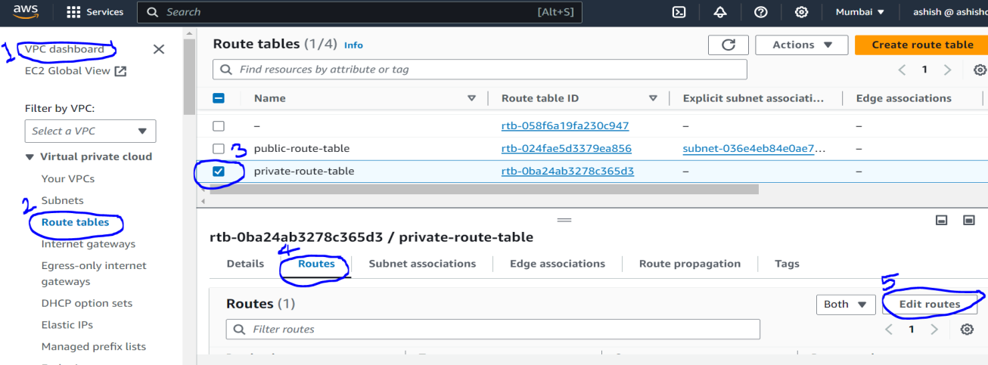

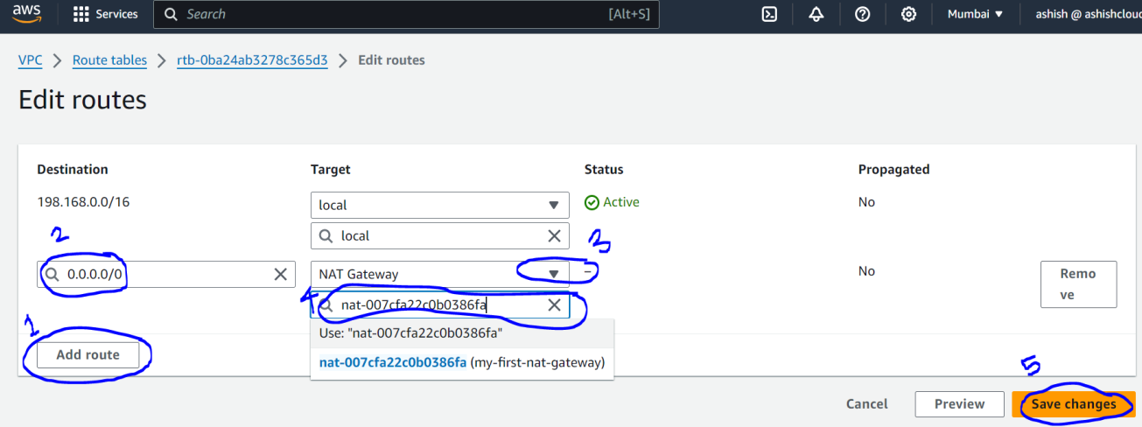

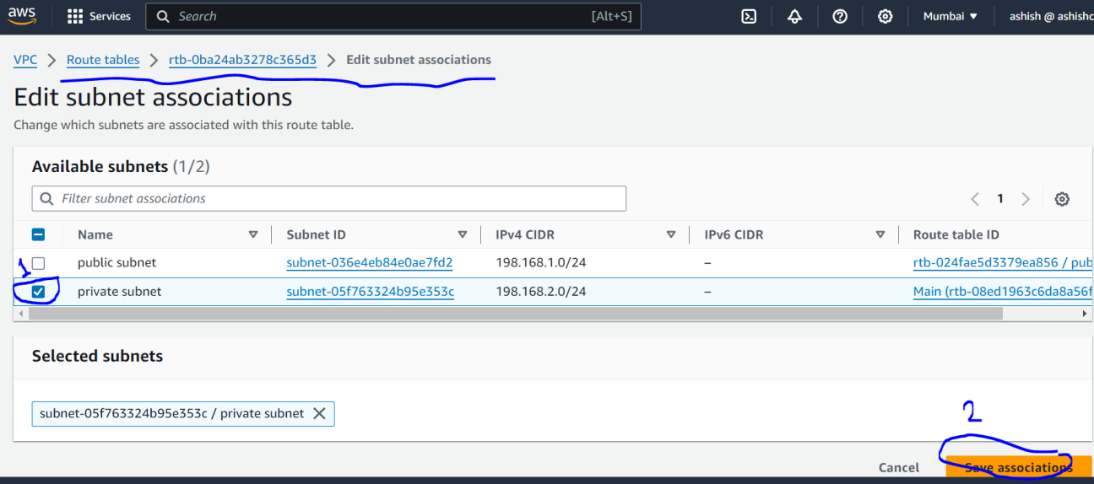

1. Create Custom Security group which allow the all traffic and also SSH.
2. Create Two EC2 instance one is in public subnet (called public ec2 instance or pubic server) and other one is in private subnet (called private ec2 instance or private server).
3. If you want to access Private EC2 instance, it is not accessible directly through internet so this purpose we have created public ec2 instance which is called Bastion/jump server.

Steps to connect from Bastion server to private server:

1. Login to bastion (public) server.
2. Then create .pem file with same name which we have create security group name or copy .pem from local to bastion server.
3. Then got private server and goto connect and copy command to connect to private server.